**CHUKWU DANIEL NONSO**

**BHU/20/04/05/0010**

**COMPUTER SCIENCE**

The PlayStation 5 (PS5) is a gaming console developed by Sony Interactive Entertainment and released in late 2020. Its product design has garnered both praise and criticism. Let's discuss its strengths, areas for improvement, and how it compares to the Xbox Series X.

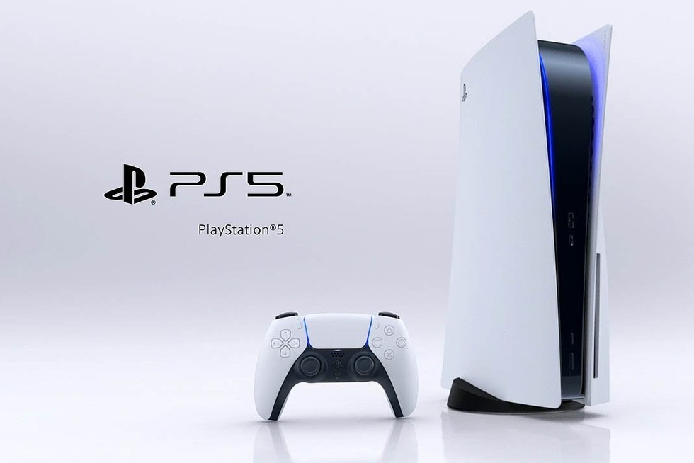

**1. What's Good About the PS5's Product Design**

Futuristic Aesthetics: The PS5 boasts a sleek, futuristic design that sets it apart from its predecessors. Its white and black color scheme, along with blue LED accents, gives it a modern and eye-catching look.

Compact Size: Despite its powerful hardware, the PS5 manages to maintain a relatively compact form factor compared to the Xbox Series X, making it more manageable to fit in entertainment setups.

Fast Loading Times: The PS5 features an ultra-fast SSD (Solid State Drive) that drastically reduces loading times in games in comparison to its predecessors which took a significantly long amount of time to load. This is a significant improvement and enhances the overall gaming experience.

The Controller: The new DualSense controller incorporates advanced haptic feedback and adaptive triggers, providing a more immersive gaming experience by allowing players to feel in-game actions and sensations.

Backward Compatibility: The PS5 supports a large library of PlayStation 4 games, allowing gamers to enjoy their existing collection without the need to repurchase titles.

**2. What Should Be Improved on the PS5's Product Design**

Size and Weight: While the PS5's design is great, it's relatively large and heavy, which can make it challenging to fit into some entertainment centers and may be less portable in comparison to older PlayStation designs.

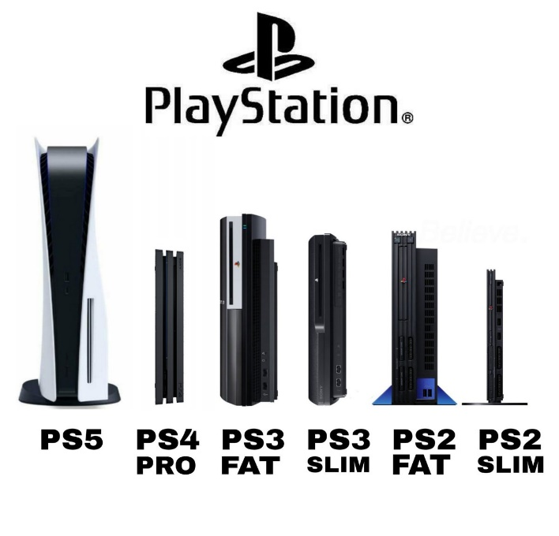

Ventilation and Noise: Some users have reported that the PS5 can get quite loud under heavy loads due to its cooling system. This is something that could be improved to provide a quieter gaming experience.

Availability and Pricing: The initial shortage of PS5 units and the pricing on the products initial release, were issues that left many potential buyers frustrated. Sony needs to address these concerns for a more seamless experience on their upcoming releases.

**3. Comparison with Xbox Series X**

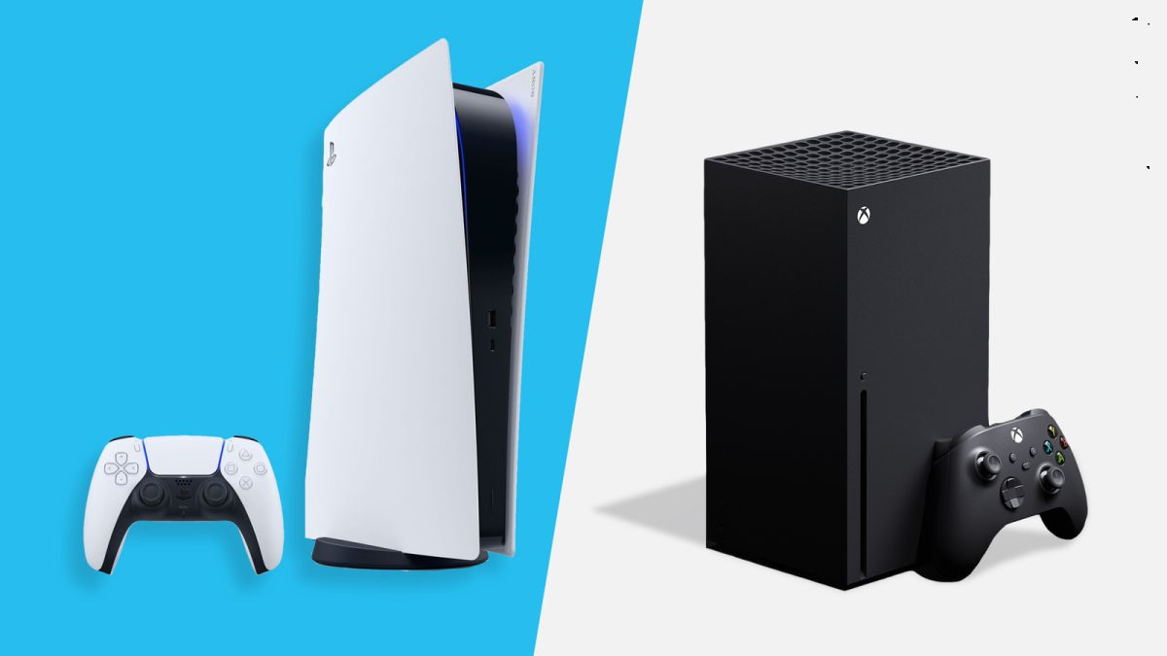

Design Philosophy: The PS5 and Xbox Series X have vastly different design philosophies. While the PS5 is sleek and futuristic, the Xbox Series X opts for a more minimalist tower design. Which design you prefer is largely a matter of personal taste.

Hardware: Both consoles feature powerful hardware, with similar CPU and GPU capabilities. However, the PS5's ultra-fast SSD gives it an edge in terms of loading times and seamless gameplay experiences.

Backward Compatibility: Both consoles support backward compatibility, but Xbox Series X has a more extensive library of backward-compatible games, spanning multiple generations of Xbox consoles.

Exclusive Game Titles: Sony has a strong lineup of exclusive titles, such as “God of War”, “Uncharted”, “Last of Us”, “Spider Man”, “Demon's Souls”, “Horizon Forbidden West”, and much more. These exclusive titles can be a significant factor for many gamers when choosing between the two consoles.

In conclusion, the PlayStation 5 has a unique and eye-catching design, along with impressive hardware features like the ultra-fast SSD and DualSense controller. However, there is room for improvement in terms of size, noise, and pricing. When compared to the Xbox Series X, it's a matter of personal preference and priorities, as both consoles have their strengths and weaknesses, particularly in terms of exclusive games and backward compatibility.